**OPEN CALL FOR PHD STUDIES**

**Doctoral School of Economic and**

**Regional Sciences**

**Head of the doctoral school:**

[**Prof. Zoltan Lakner**](https://www.scopus.com/authid/detail.uri?authorId=6506033503)

**PhD Studies**

The doctoral degree awarded by Hungarian University of Agriculture and Life Sciences (MATE) is an internationally recognized PhD degree. Our professional staff has a good reputation all over the world.

**Doctoral School of Economic and Regional Sciences**

Our PhD programme consist of 2+2 years. The ﬁrst 2 years are completed by a complex exam at the end of the 4th semester. In the last 2 years, PhD students' effort will be focused only on research, publications and writing a dissertation.

|  |  |
| --- | --- |
| **Year 1** | **Study and research phase:**  **- Courses**  **- Literature review**  **- Research,**  **- Development of final research work plan**  **min. 120 credits** |
| **Year 2** |
| **Complex Exam – Application for Complex Exam via Neptun!** | |
| **Year 3** | **Research and dissertation phase:**  **- Research**  **- Publications**  **min. 120 credits** |
| **Year 4** |
| **Final certificate – 240 credits (absolutorium)** | |
| **Defence** | |

**Courses**

*Compulsory*

Economics, Research Methodology, Managerial Economics, Regional Economics

*Optional*

Bioeconomy, Methods of Economic Sciences, Supply Chain Management, Finances, Marketing and Marketing Research, Methods of Social Sciences, Tourism Management, Entrepreneurship and Business Models, Management Accounting and Controlling, Management Organization and Human Resource Management, Rural Development Policy

**Publications**

The output requirement of the doctoral student's research activity: at least 4 scientific articles. The student is first or last in at least 2 published scientific articles must be a corresponding author. In the case of articles Q1, Q2 and Q3, the DIT decides how many are accepted triggers other articles. Published in a maximum of 1 book with an ISBN number a book chapter can replace 1 article (a book chapter is equivalent to an article).

More details:

**Prof. Robert Magda PhD (**[magda.robert@uni-mate.hu](mailto:magda.robert@uni-mate.hu)**)**

**International program leader**

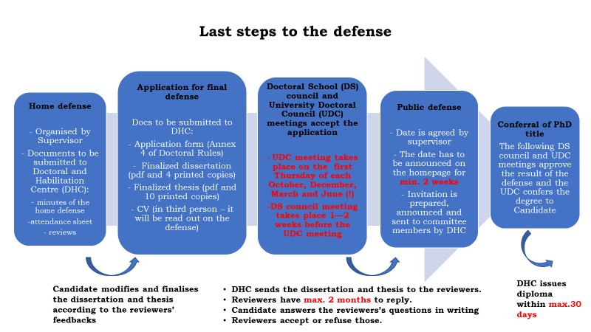

**HOW TO APPLY FOR DOCTORAL STUDY?**

Fill in the application form and send it with the required attachments to [phd@uni-mate.hu](mailto:phd@uni-mate.hu)

[APPLICATION FORM](https://archive.uni-mate.hu/sites/default/files/application_form.docx)

**REQUIRED ATTACHMENTS:**

**1.) RECEIPT OF PAYMENT OF REGISTRATION FEE**

The registration fee is EUR 100, which should be transferred to:  
Number of Bank Account: 11784009-22234780-00000000  
Name of Bank Account: Magyar Agrár- és Élettudományi Egyetem  
Name and Address of Bank: OTP Bank 1051 Budapest, Nádor u. 6.  
IBAN: HU36- 11784009-22234780-00000000  
SWIFT Code: OTPVHUHB  
In the comments field, please write PHDREG + your name and the name of the programme for which you have applied.

**2.) RESEARCH PROGRAM**  
It is a specimen sheet which you have to fill out and your research program must be carried out accordingly (max. 4-5 pages). (the scheme is included in the Application form)

**3) REFERENCES**  
All candidates must provide two letters of academic references, signed and sealed by faculty members or relevant scientists who are familiar with the candidate’s work and character. The university strongly advises candidates to include the letters in their application materials in order to avoid delay and possible rejection of application due to incompleteness.

**4) TRANSCRIPTS**  
An official copy of the transcripts from all higher-education institutions previously attended by the candidate must be submitted, either attached to the application or by mail directly from the originating institution.

**5) LANGUAGE REQUIREMENTS**

Communication is the key to educational success and, therefore any foreign or Hungarian PhD student is expected to have proficient written and spoken language skills in English (B2 level of English is required (i.e. TOEFL min. of 500 on PBT, 61 on iBT; a 6.0 on IELTS or equivalent including completion of previous level of studies in English e.g.  GCSE or BSc or MSc) , but in a few cases other world languages like French, German, Russian or Spanish can be acknowledged as well.

**INTERVIEWS**  
International candidates may be requested a formal interview.

**(19.08.2022. ONLINE)**

**CONDITIONAL ACCEPTANCE**  
Candidates will be sent a tentative acceptance if the university wishes them to continue their studies there. This acceptance becomes formal upon receipt of annual fees.

**PAYMENT OF FEES**  
Payment of the first semester fee must be completed before starting the studies. This can be done by bank transfer to the following account number:  
Number of Bank Account: 11784009-22234780-00000000  
Name of Bank Account: Magyar Agrár- és Élettudományi Egyetem  
Name and Address of Bank: OTP Bank, 1051 Budapest, Nádor u. 6.  
IBAN: HU36- 11784009-22234780-00000000  
SWIFT Code: OTPVHUHB

In the comments field, please write your name and the name of the program for which you have applied.  
Confirmation of receipt will be provided upon the clearance of the transfer or check.

**APPLICATION DEADLINE: 18.08. 2022.**

**CONTACT:**

**Doctoral and Habilitation Centre  
H-2100 Gödöllő, Páter K. u. 1. Hungary  
Phone 36 28 415-382  
E-mail:** [**phd@uni-mate.hu**](mailto:phd@uni-mate.hu)